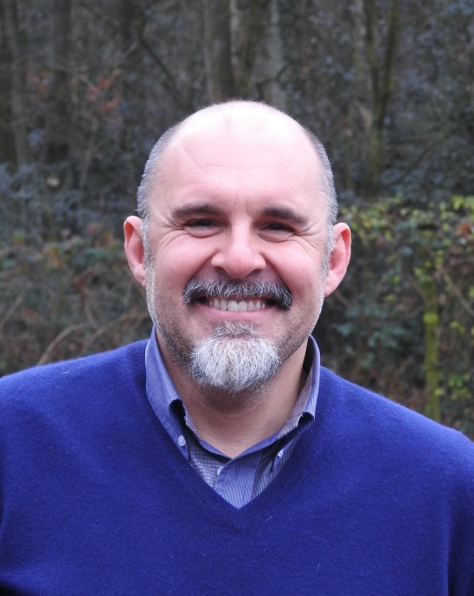

Dr. Denis Necchi, DVM, Dipl. ECAR
1996: Veterinary Degree at the University of Milan
1996-2006:Veterinary resident at Studio Veterinario Cristella
2005: Diploma European College of Animal Reproduction
2006: partner of Select Breeders Services Italia
2013-2015: Assistant Professor in Equine Reproduction
2015 : Avantea (Laboratory of animal reproduction)
2016-2018: Veterinary Resident at Broline (breeding farm) Sweden
2019: Veterinary resident at KEROS (BE)

His interest is equine theriogenology involving semen freezing, fertility of the stallion and mare, broodmares management, Embryo Transfer and Ovum Pick Up.
He always attends national and international convention also as an invited speaker.
Speaker and instructor in courses of Equine Reproduction. Author and co-author of several publications in international journals and other material of equine reproduction.

